**1. Top right corner of Wet Kitchen:**

Upload speed:

Download speed:

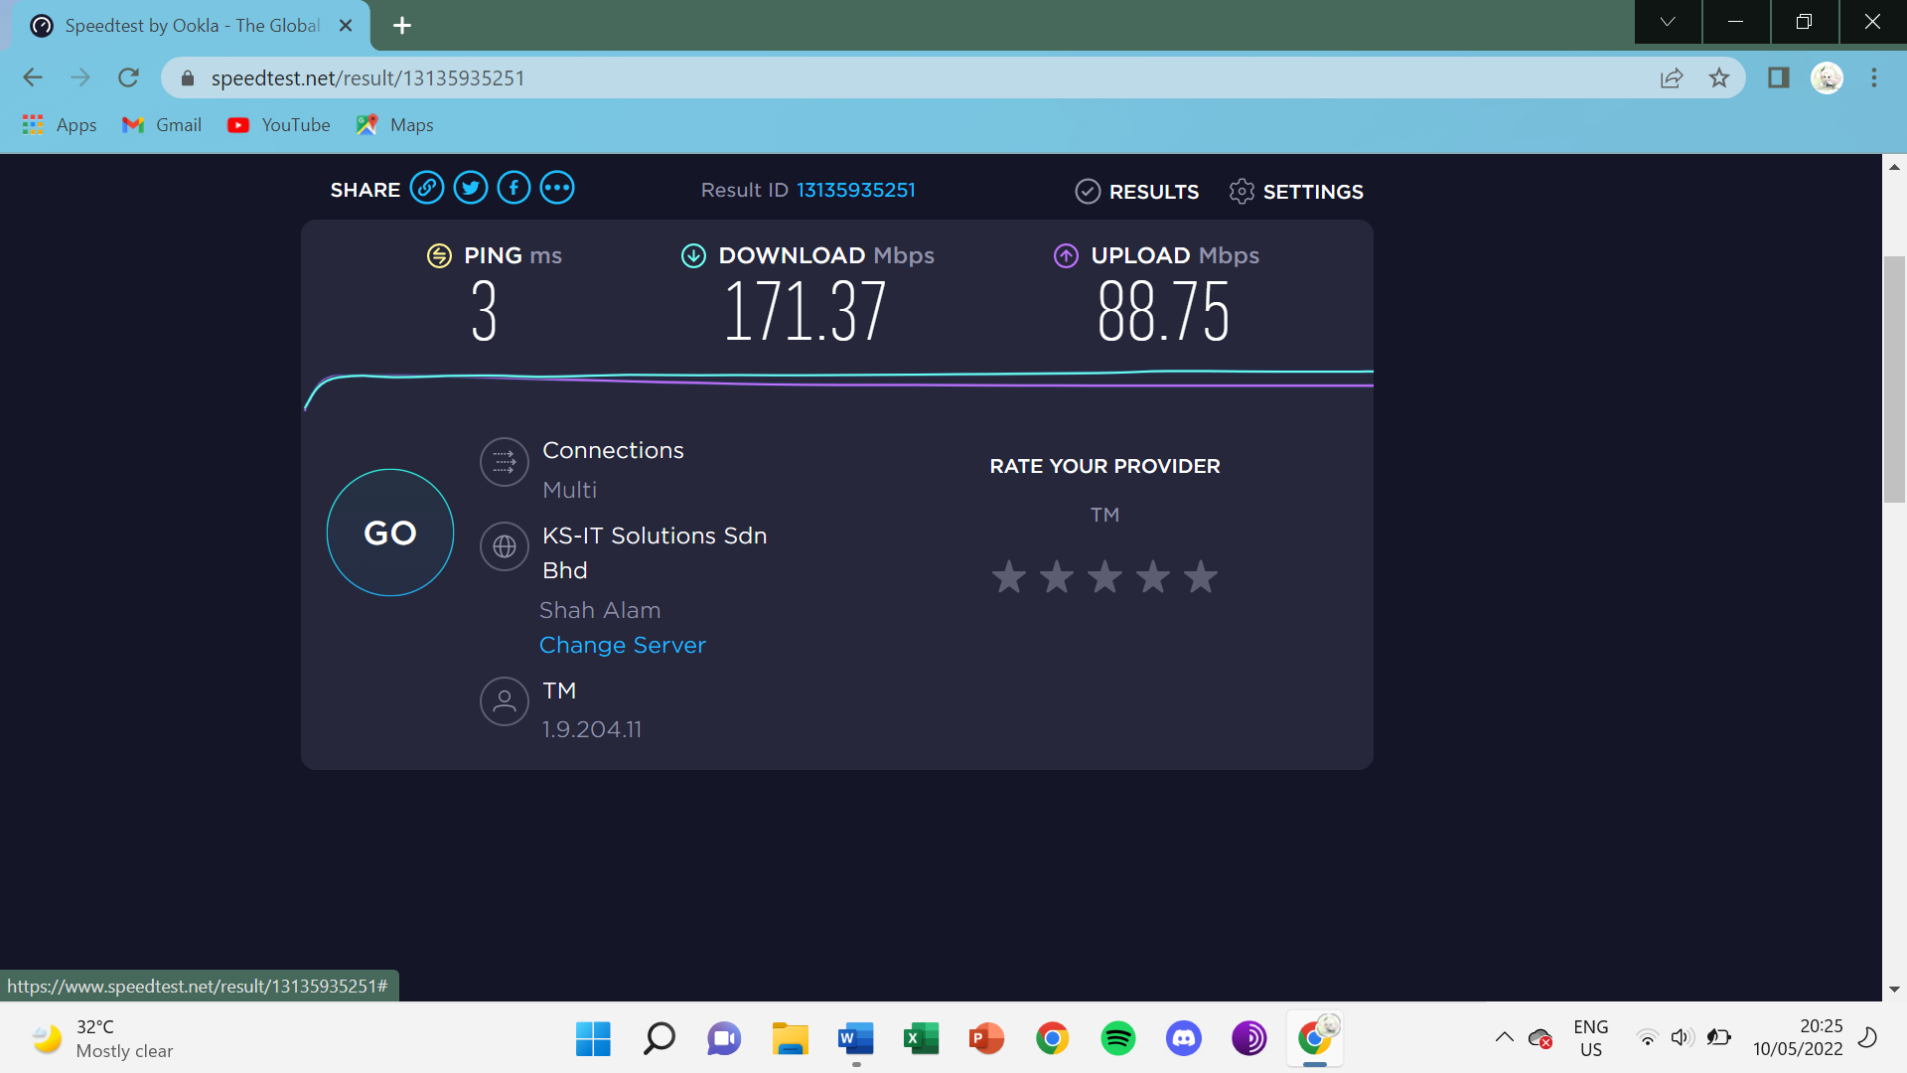

Mommy’s : 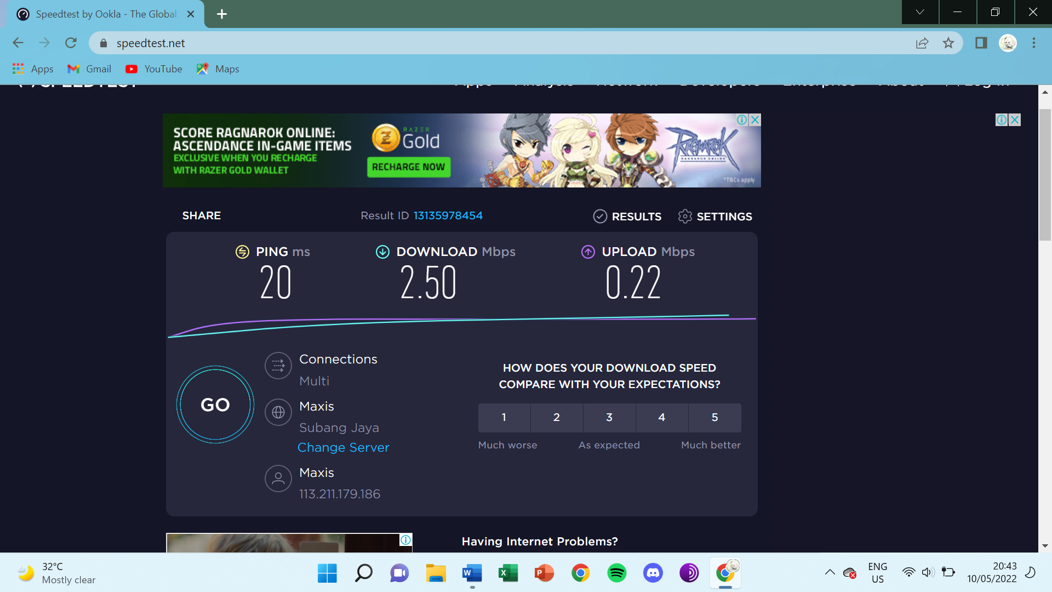

Mine: Too weak to test

**2. Top left corner of Guest Bedroom:**

Upload speed:

Download speed:

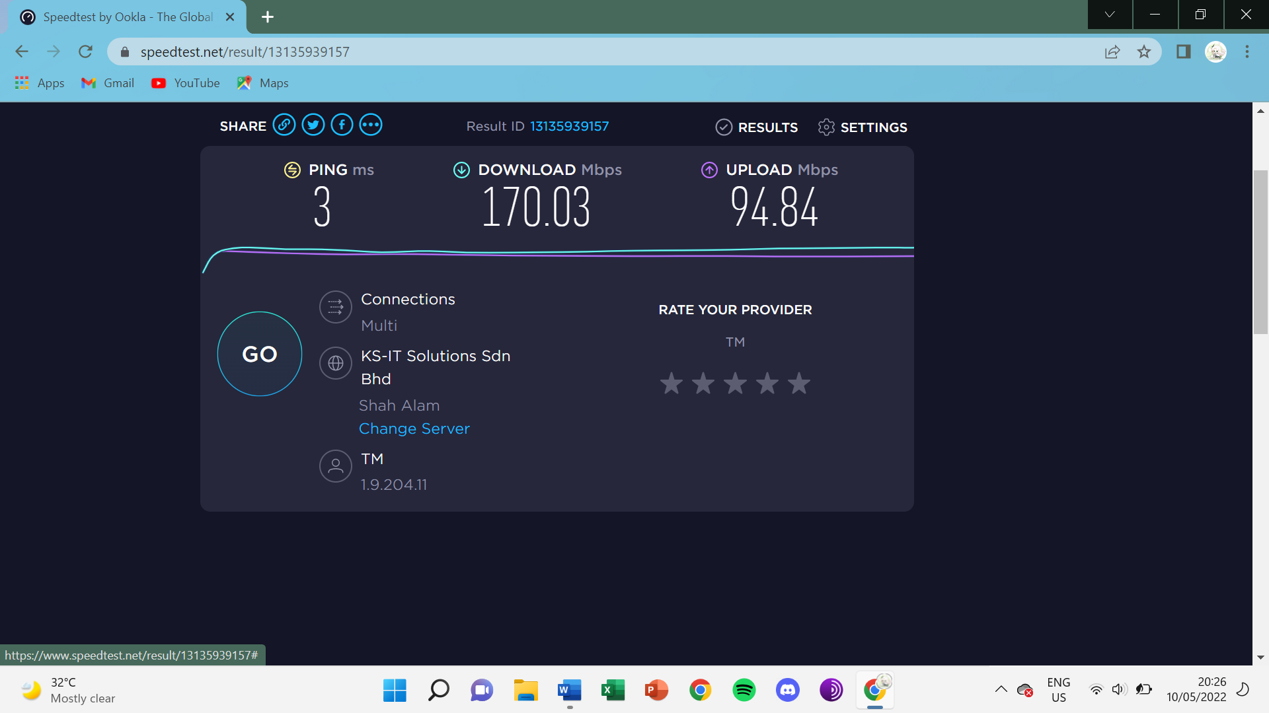

Mommy’s : 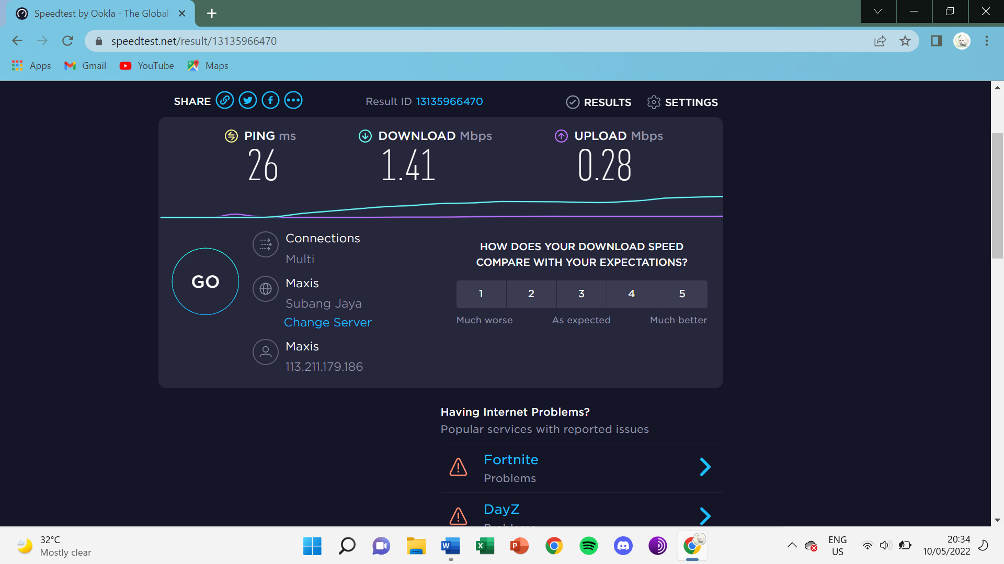

Mine : Too weak to test

**3. Bottom left corner of stairs:**

Upload speed:

Download speed:

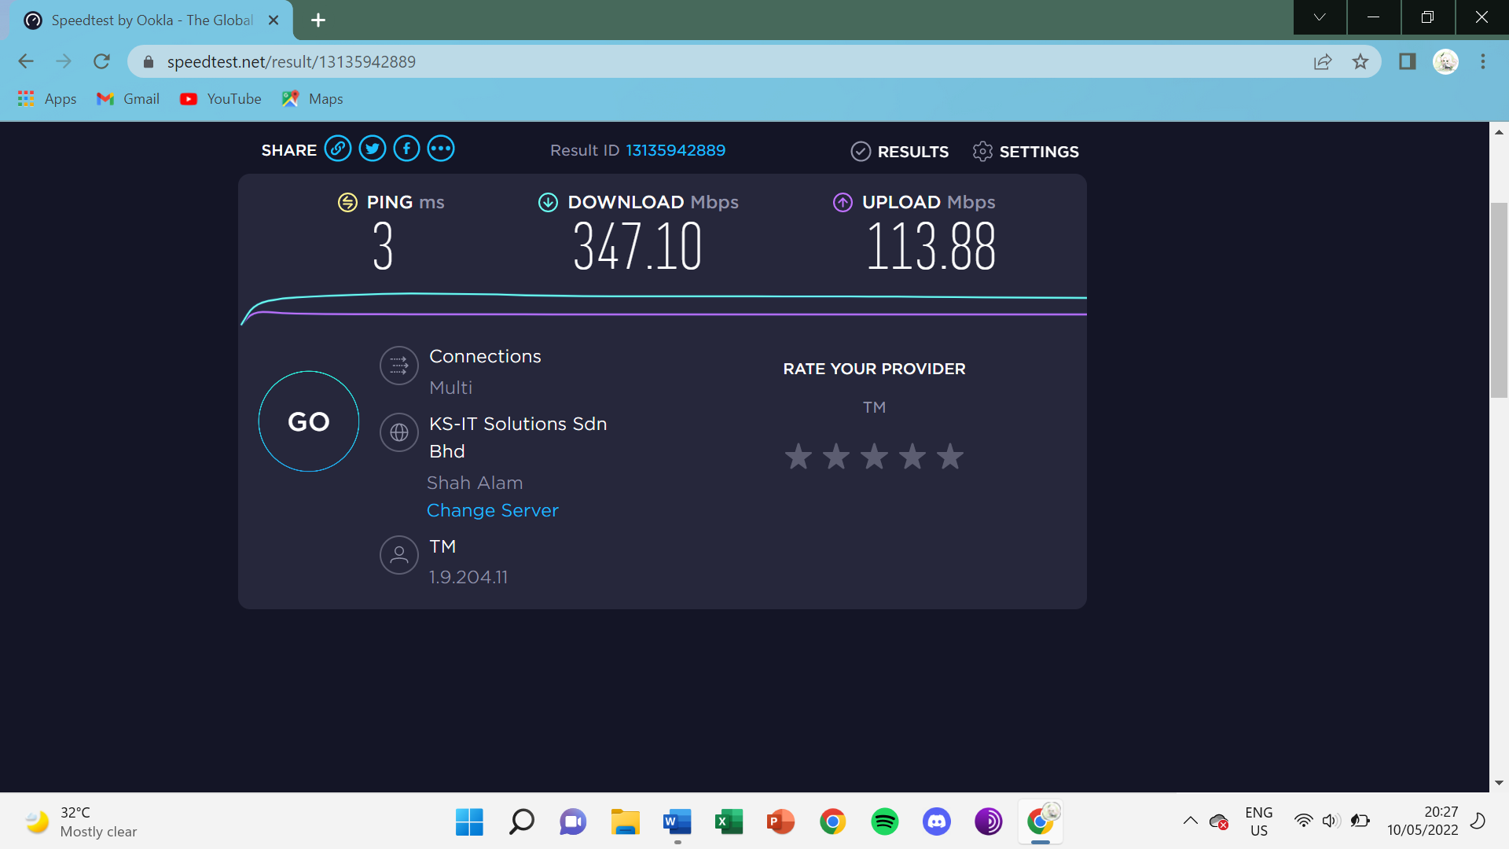

Mommy’s : Too Weak to test

Mine’s : 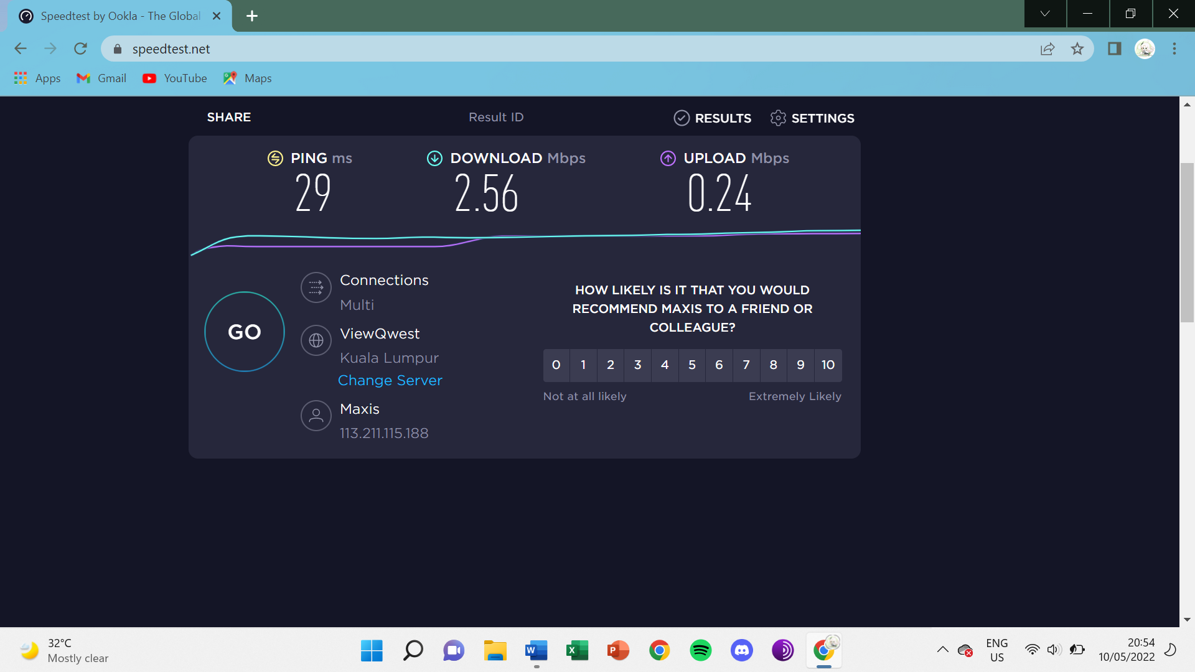

**4. Middle part of above Dining room:**

Upload speed:

Download speed:

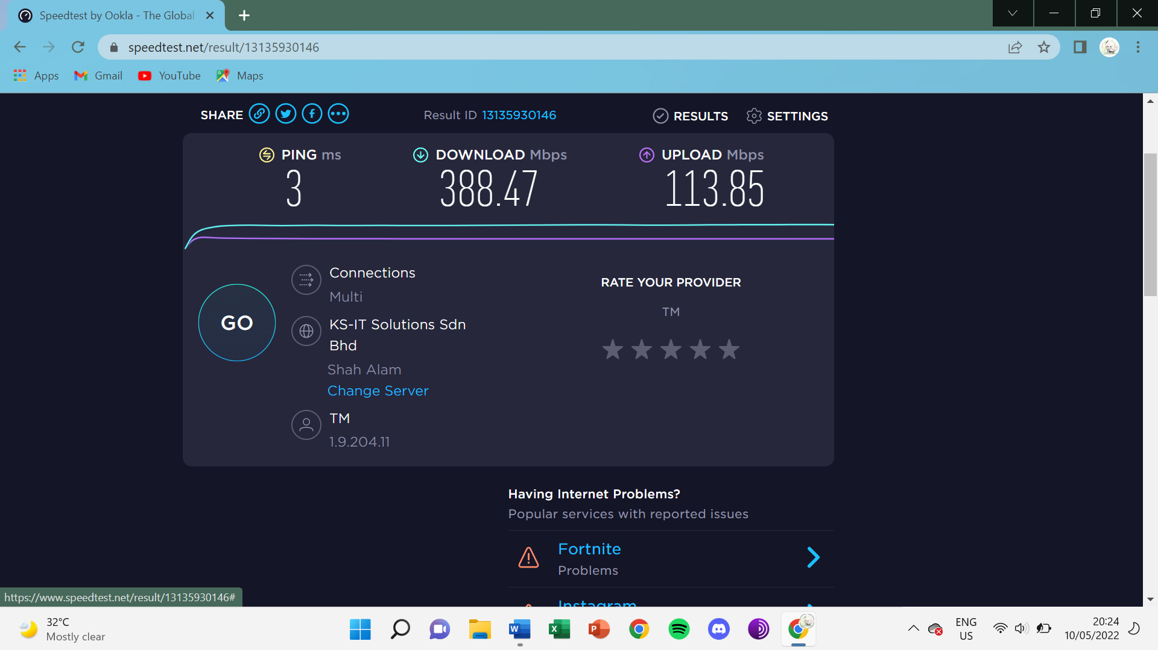

Mommy’s: 

Mine: 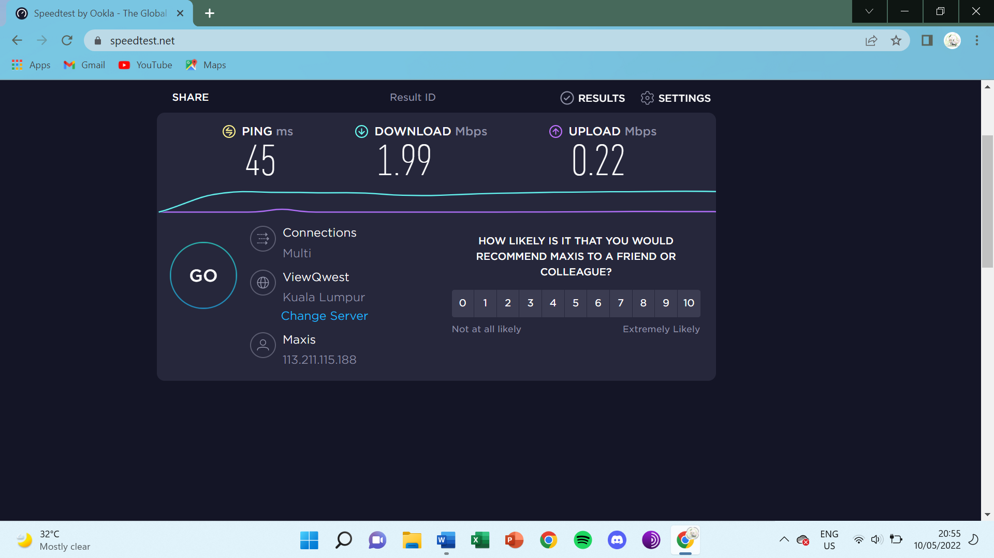

**5. Middle of Dining room (on top of dining table):**

Upload speed:

Download speed:

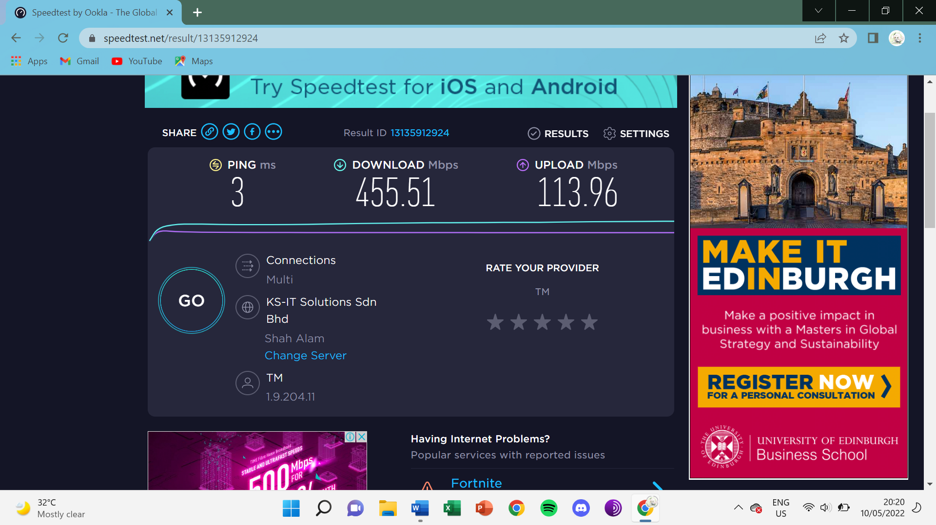

Mommy’s: 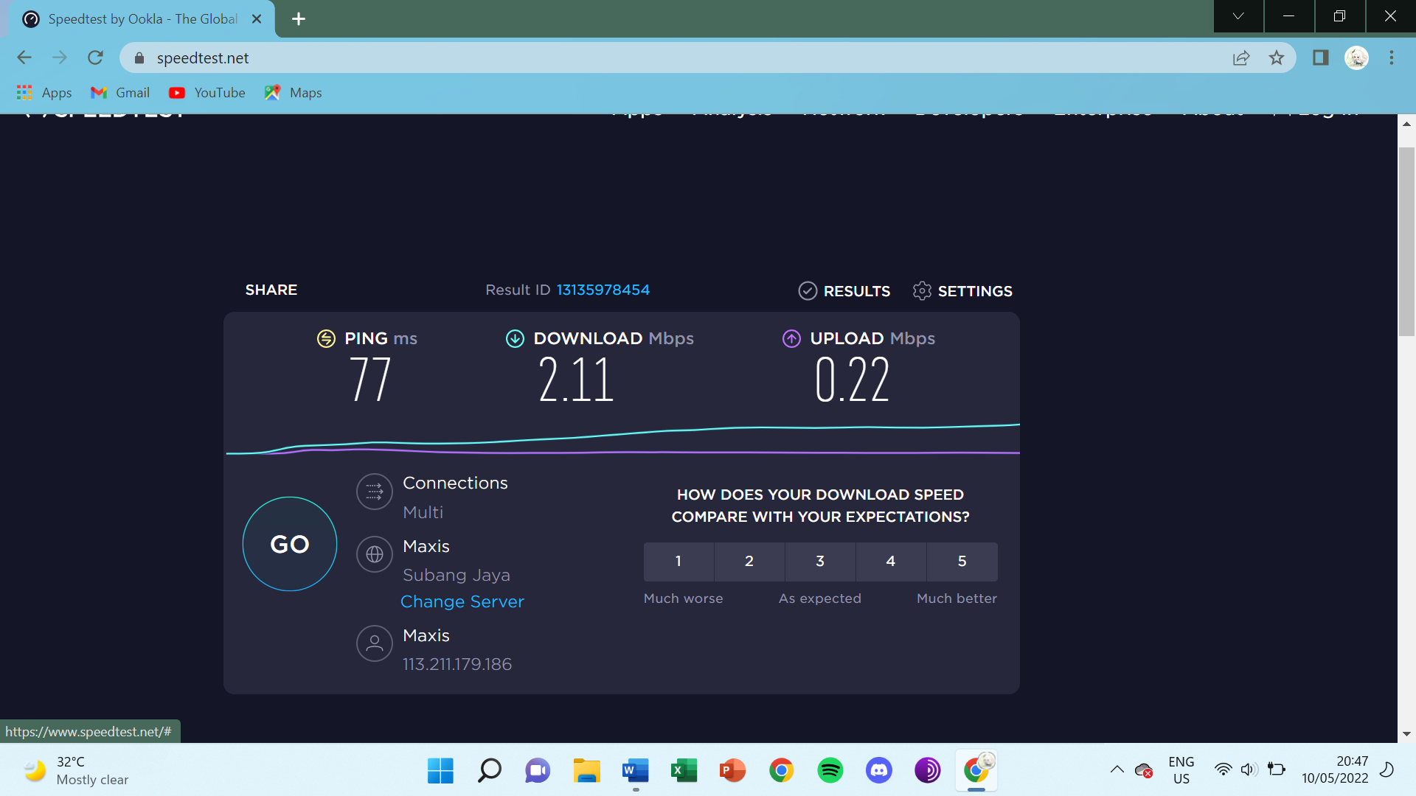

Mine: 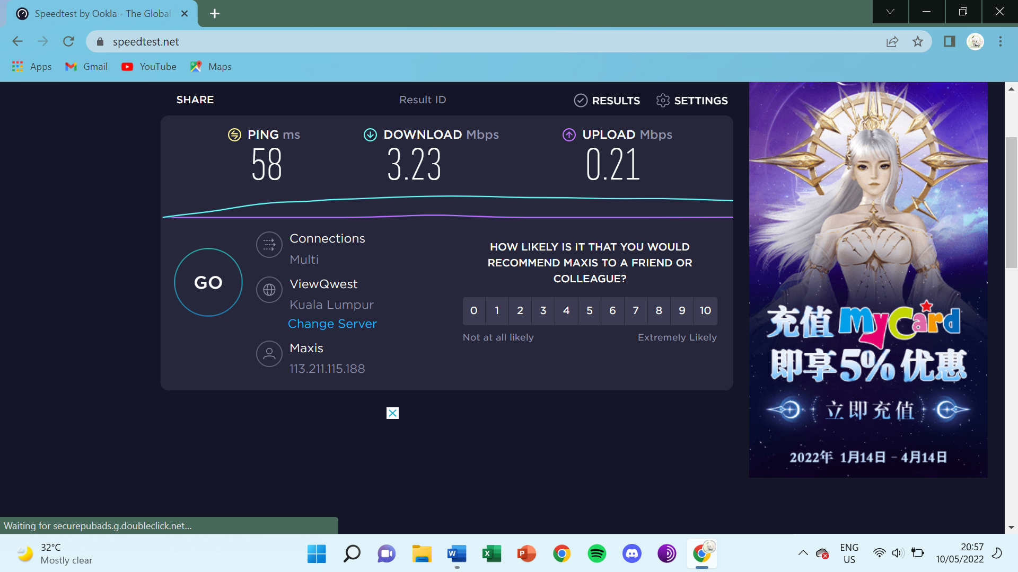

**6. Right side near fence wall of side garden:**

Upload speed:

Download speed:

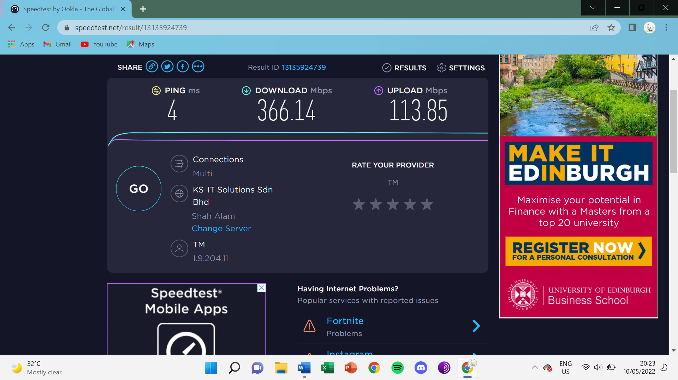

Mommy’s:

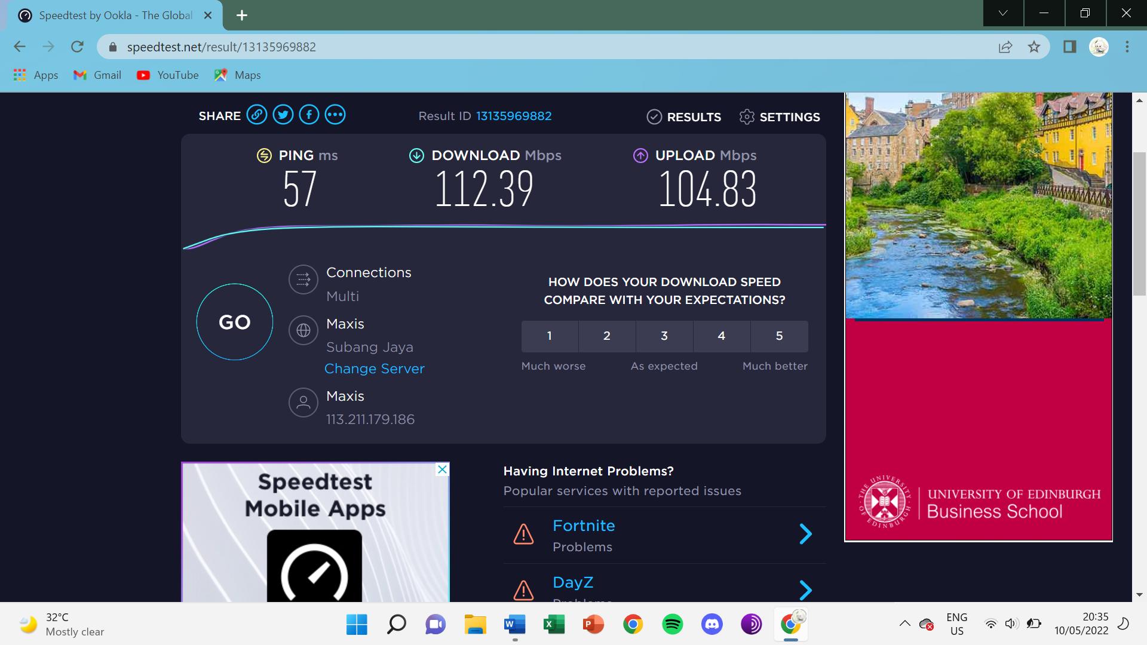

Mine: 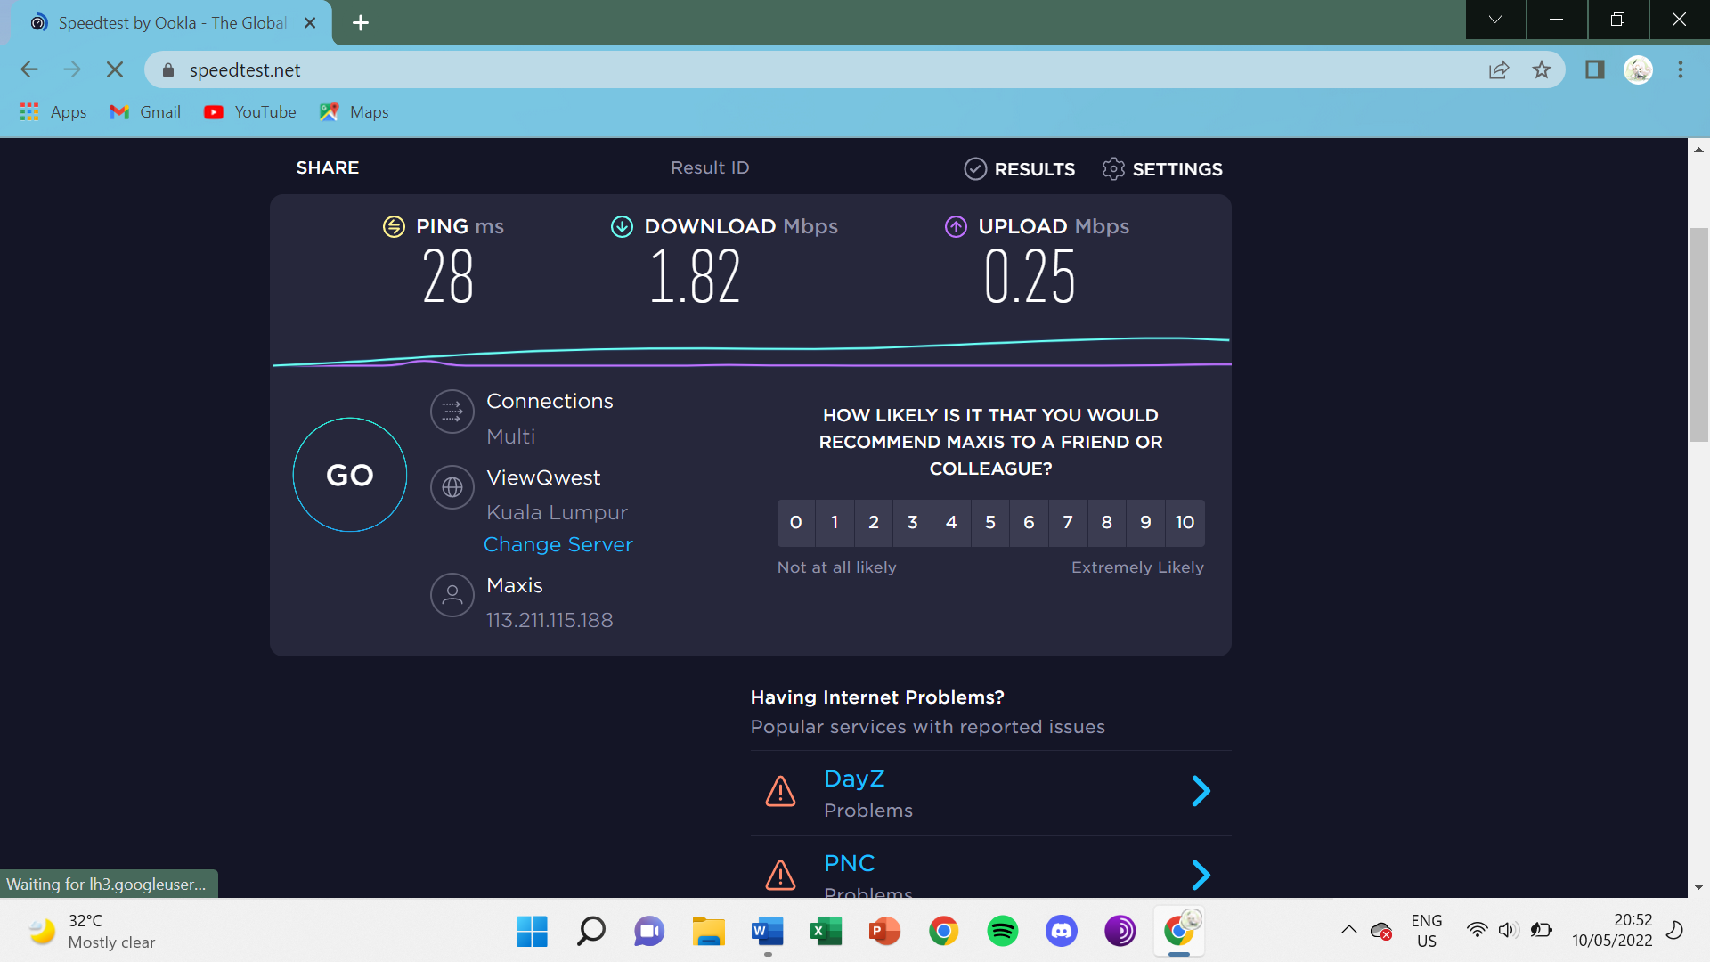

**7. Bottom left corner of Car Porch:**

Upload speed:

Download speed:

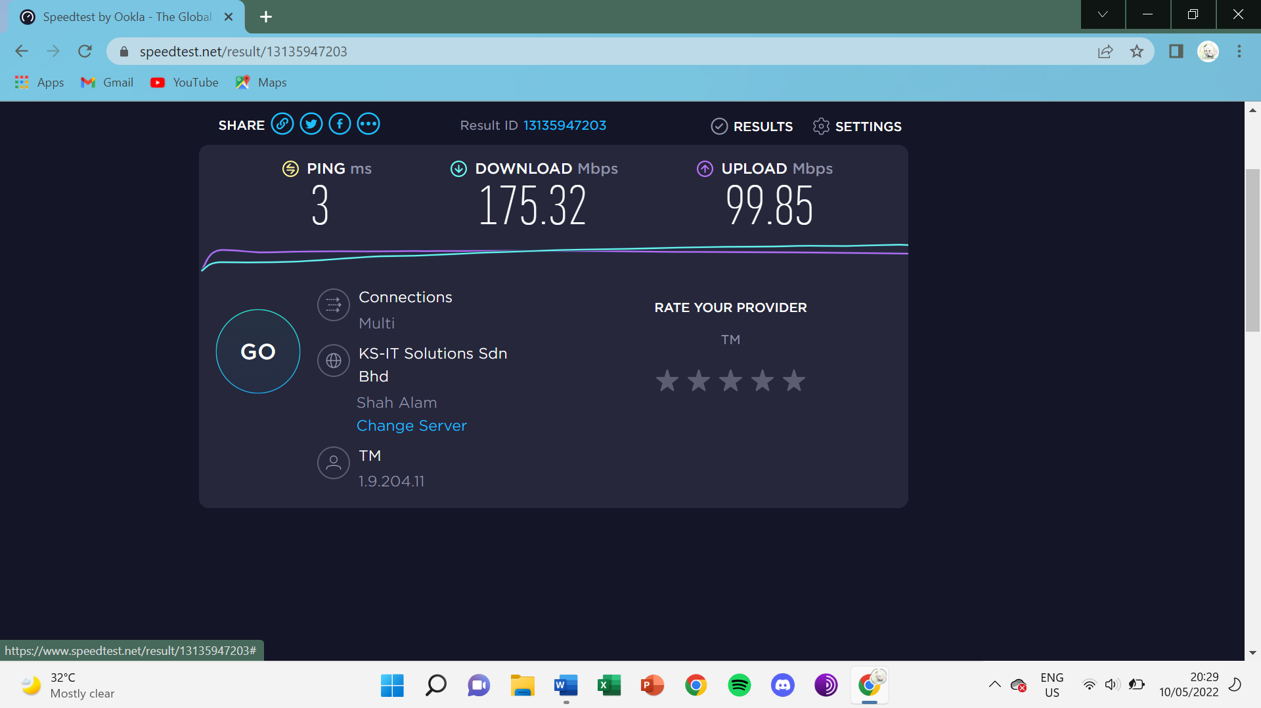

Mommy’s : Too weak to test

mine’s : Too weak to test

**8. Bottom right corner of Car Porch:**

Upload speed:

Download speed:

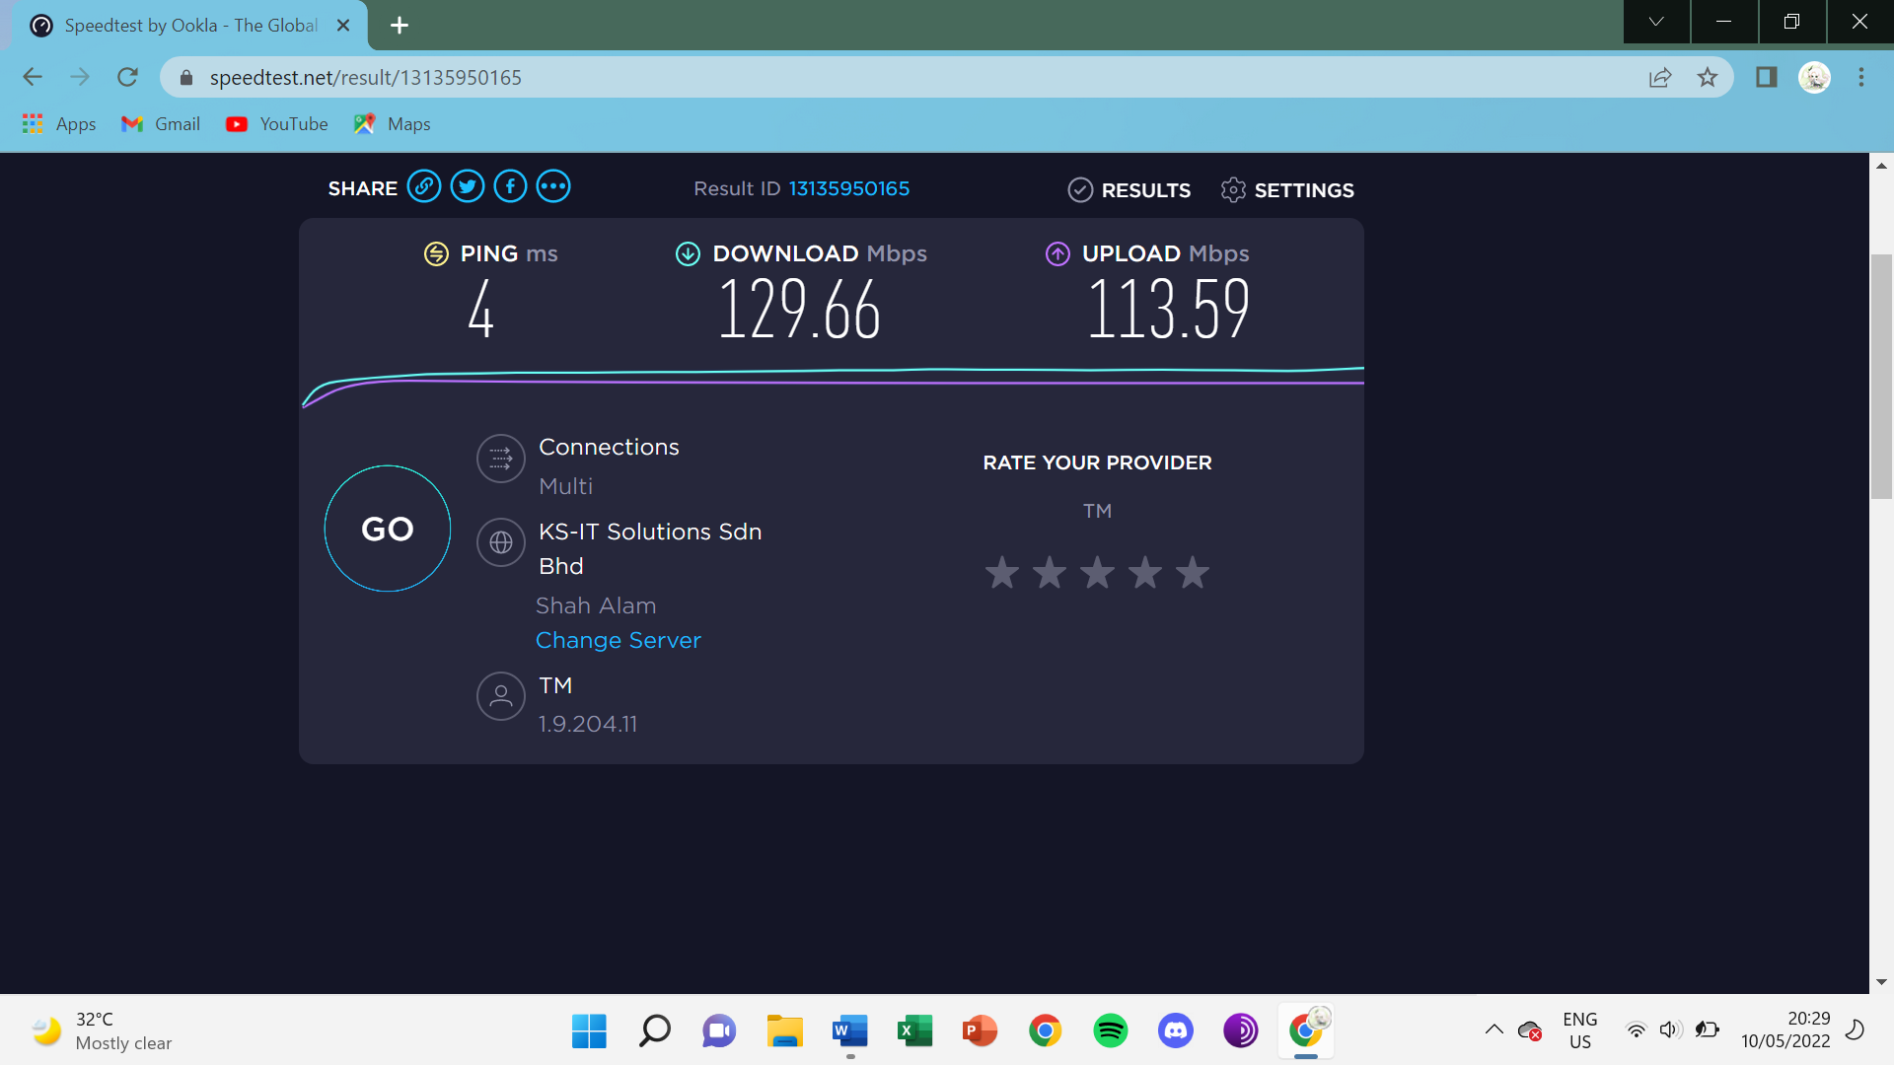mommy’s : Too weak to testmine’s : Too weak to test